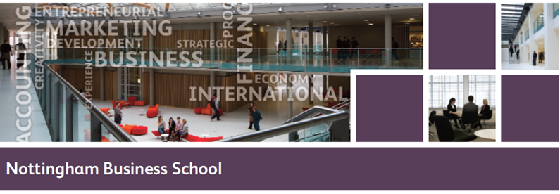

**ALUMNI FELLOWSHIP**

As the UK’s foremost **business school for business**, NBS prides itself on providing our communities with industry insight and opportunities to widen their exposure to real businesses and their leaders.  The Nottingham Business School Alumni Fellowship Programme is an outstanding opportunity for our alumni to engage with NBS students and staff individually and as a whole population.  Alumni Fellows are asked to offer their services for a minimum of 2 working days to undertake a range of activities to enrich our student and staff experience and professional development.  Activities will include:

**Mentoring: *undergraduate and graduate programmes, running between June to April/two days required***

An opportunity to share your professional knowledge and experience with our students. As a mentor, you fulfil several roles which include motivator, resource, supporter and coach. You respond consistently, openly and honestly to your mentee providing sensitive challenge where appropriate. Full training will be given through the NTU Employability Mentoring Scheme.

**Recruitment fair support: *autumn and summer term/half day required***

Contribute to our recruitment fairs through providing informal information/advice to our students about what employers are looking for, tips and advice on making applications and speaking at workshops on the day.

**Assessment Centre support (undergraduate and postgraduate): *autumn, spring and summer term/half day required***

Assist NBS during assessment centres where students complete a range of activities, such as interview and aptitude tests. You will be part of a group of observers running the activities and tests to identify individuals possessing the skills that the organisation needs. These centres all contribute to raising our students employability and preparing them for their futures.

**Interviewing (Acceler8, mock employment interviews): *autumn, spring and summer term/half day required***

Help improve our students’ employability prospects through sitting on our mock interview panels where students receive valuable feedback about their performance to help them improve their techniques at further interviews.

**Company visits and shadowing: *autumn, spring and summer term/one day required***

Arrange for student groups to visit your organisation so that they can experience a real, functioning operation. Or dedicate time for an individual student to shadow you in your workplace so that they can gain first-hand work experience.

**Course Enhancement boards: *meets in June/half day required***

The Course Enhancement Board meets once a year to focus on course currency and relevance. It takes a strategic focus to identify medium and long-term changes to the course structure and curriculum. The Board consists of the Course Management Team, Employers, Alumni and Student Representatives. The role of the Alumni representatives is key as individuals who have completed the course and several years in employment, Alumni can draw upon this combined experience to help the board identify potential changes to curricula and other course enhancements to maintain relevance to the world of business.

**Guest lectures/seminar support: *autumn, spring and summer term/half day required***

Share your experiences with current students by delivering a guest lecture or career talk.

**Academic/Industry ‘buddying’: *autumn, spring and summer term/three days required***

Gain and provide an alternative viewpoint to our team of academics through our academic/industry buddying scheme which develops business and academic staff through a common interest, trust and credibility.